Day 5 – Problem Solving Techniques and Data Structures – I
Set 1 – Retail Inventory and Product Reviews

Task 1 – Database Normalisation and ER Diagram
1. Normalisation up to 3NF
The original spreadsheet is divided into five separate tables to avoid duplicate data.
- Supplier
- Category
- Warehouse
- Product
- Inventory
2. Database Anomalies
- Insertion Anomaly: Cannot add supplier details without adding a product.
- Update Anomaly: Changing a supplier's phone number requires updating multiple rows.
- Deletion Anomaly: Deleting a product may accidentally remove supplier details.
3. Relationships
- Supplier → Product (One-to-Many)
- Category → Product (One-to-Many)
- Product → Inventory (One-to-Many)
- Warehouse → Inventory (One-to-Many)
4. ER Diagram
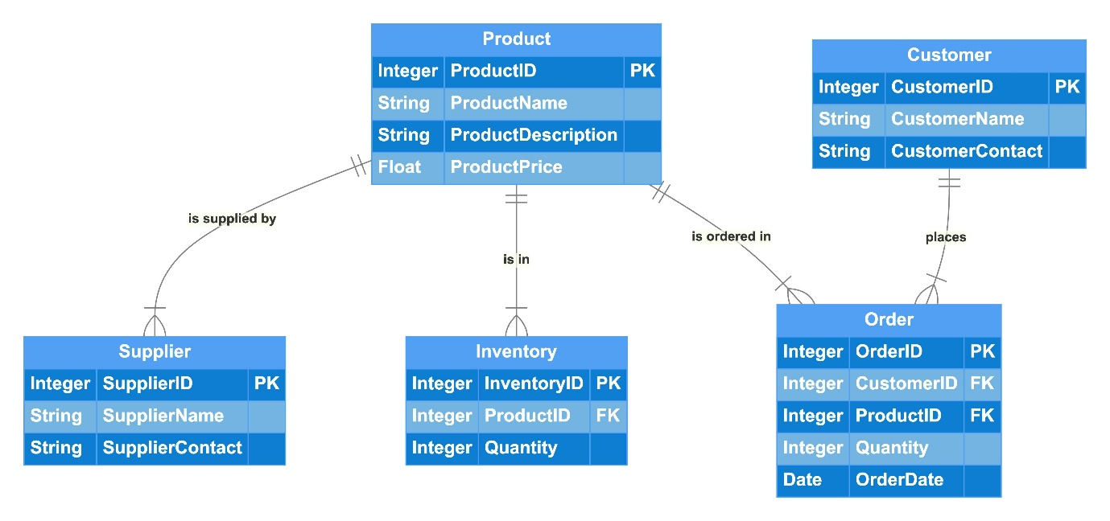
Task 2 – Database Creation and Constraints
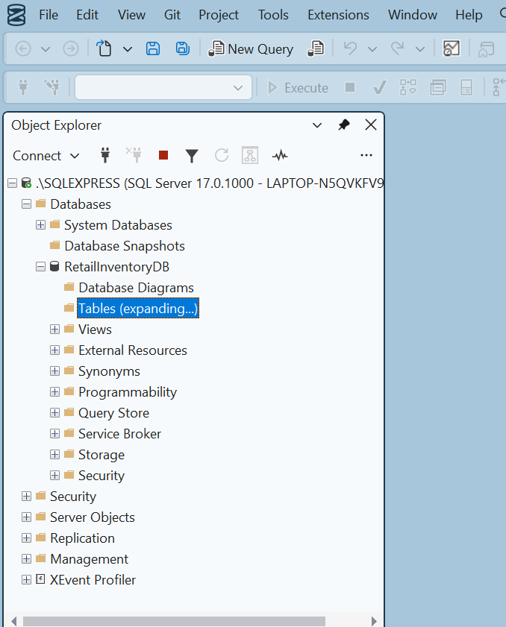
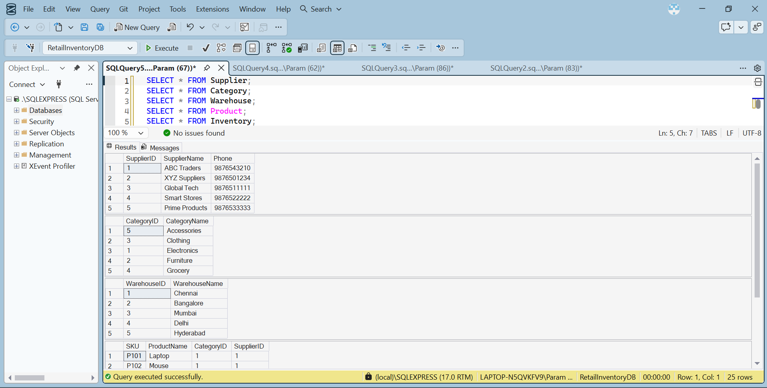
Task 3 – Data Insertion and Constraint Validation
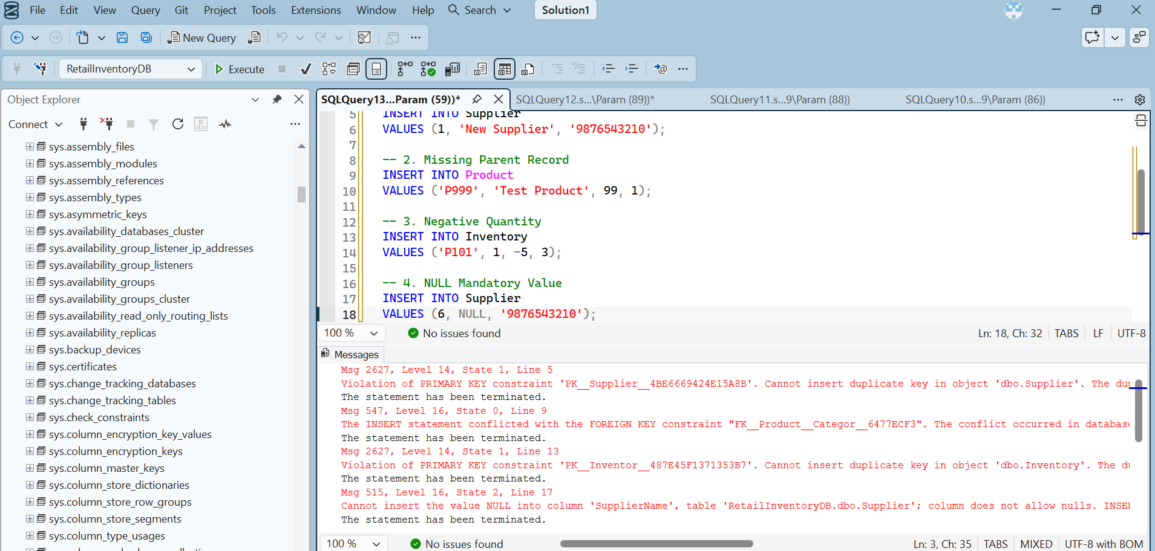
What I have done
1. Duplicate Primary Key: Tried inserting an existing SupplierID (1) into the Supplier table. SQL Server rejected it because primary key values must be unique.
2. Foreign Key Violation: Tried inserting a Product with a CategoryID that does not exist in the Category table. SQL Server rejected it because the referenced category was missing.
3. Duplicate Composite Primary Key: Tried inserting an existing SKU and WarehouseID combination into the Inventory table. SQL Server rejected the duplicate combination.
4. NOT NULL Violation: Tried inserting a Supplier record without a SupplierName. SQL Server rejected it because SupplierName cannot contain NULL values.
Result
All four invalid INSERT operations were rejected successfully. This confirms that SQL Server constraints maintain data accuracy, consistency and integrity.
Task 4 – UPDATE and DELETE
Part A: UPDATE supplier phone number
USE RetailInventoryDB;
GO
SELECT * FROM Supplier
WHERE SupplierID = 1;
UPDATE Supplier
SET Phone = '9999988888'
WHERE SupplierID = 1;
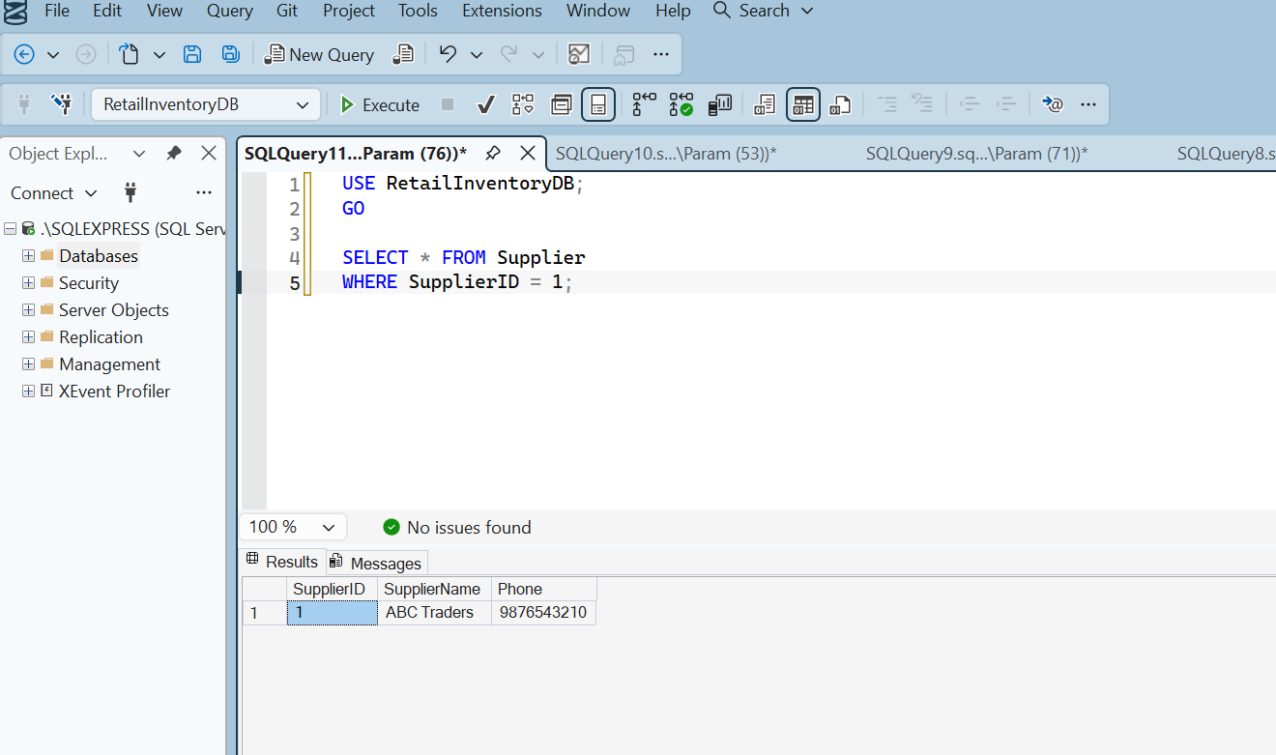
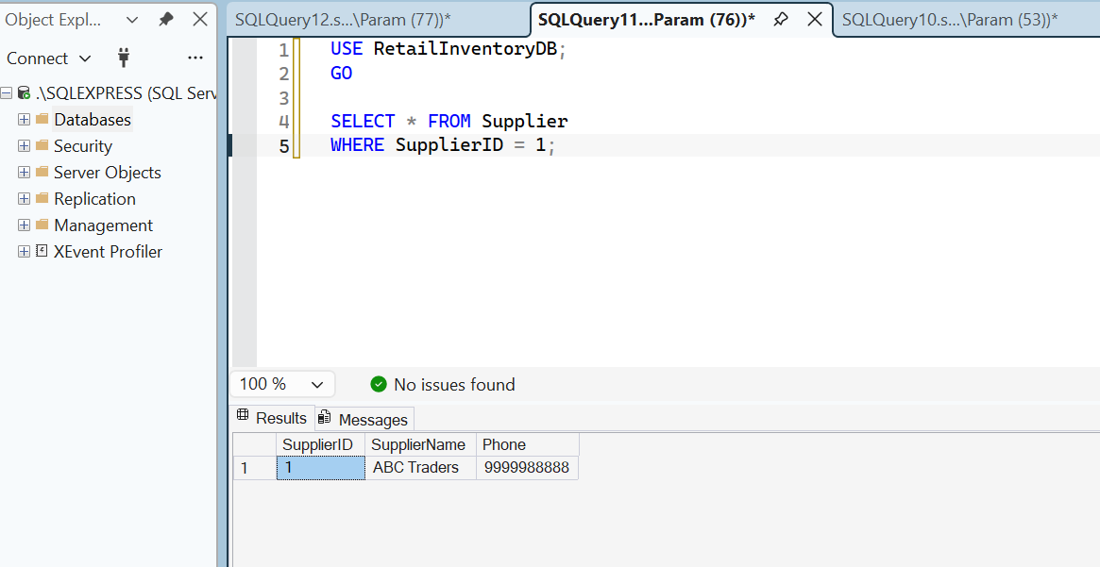
Product BEFORE deletion
We are going to remove discontinued product P105 (Table).
Before deleting, capture its details.
USE RetailInventoryDB;
GO
SELECT * FROM Product
WHERE SKU = 'P105';
SELECT * FROM Inventory
WHERE SKU = 'P105';
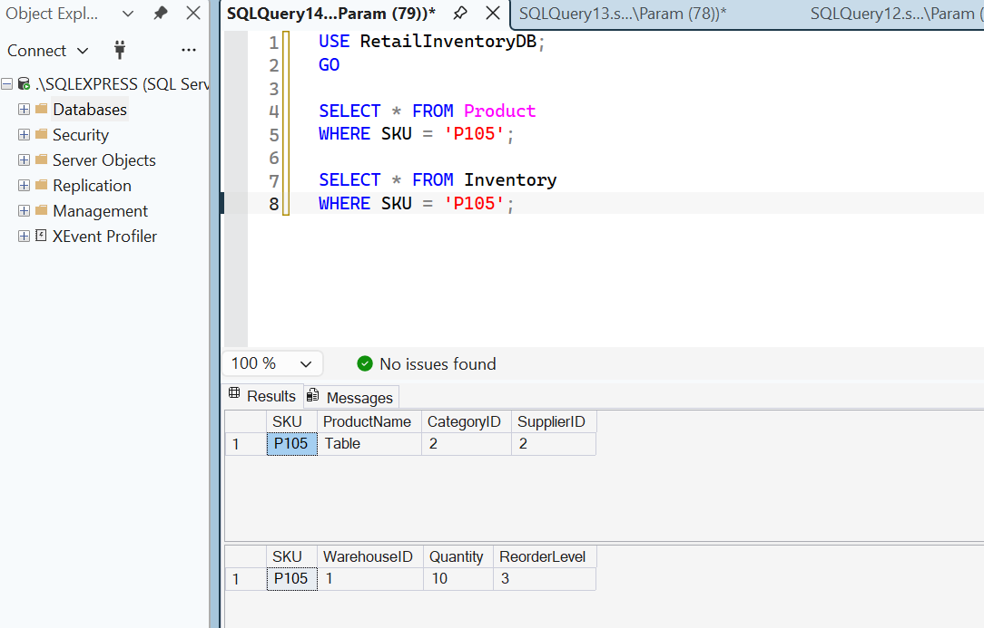
Expected results:
- Product: P105 – Table
- Inventory: Quantity 10, ReorderLevel 3
DELETE the discontinued product
SELECT * FROM Product
WHERE SKU = 'P105';
SELECT * FROM Inventory
WHERE SKU = 'P105';
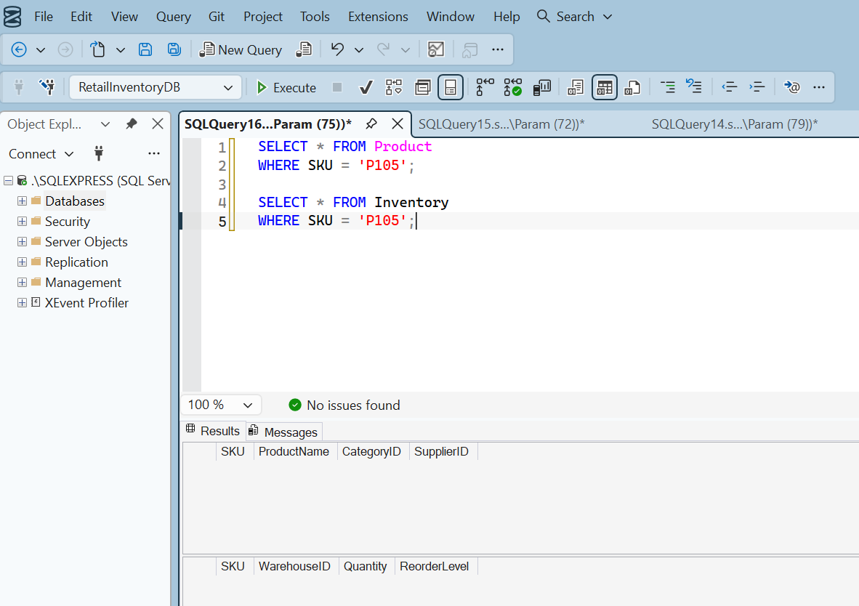
Task 5 – MongoDB Product Reviews
- Create a reviews collection.
- Apply a JSON Schema validator.
- Perform insertMany().
- Perform find().
- Perform updateOne().
- Perform deleteOne().
Create database and reviews collection
use RetailInventoryDB
db.createCollection("reviews", {
validator: {
$jsonSchema: {
bsonType: "object",
required: ["SKU", "CustomerName", "Rating", "ReviewText"],
properties: {
SKU: {
bsonType: "string"
},
CustomerName: {
bsonType: "string"
},
Rating: {
bsonType: "int",
minimum: 1,
maximum: 5
},
ReviewText: {
bsonType: "string"
}
}
}
}
})
This creates a reviews collection with validation rules:
- SKU must be text.
- CustomerName must be text.
- Rating must be an integer between 1 and 5.
- ReviewText must be text.
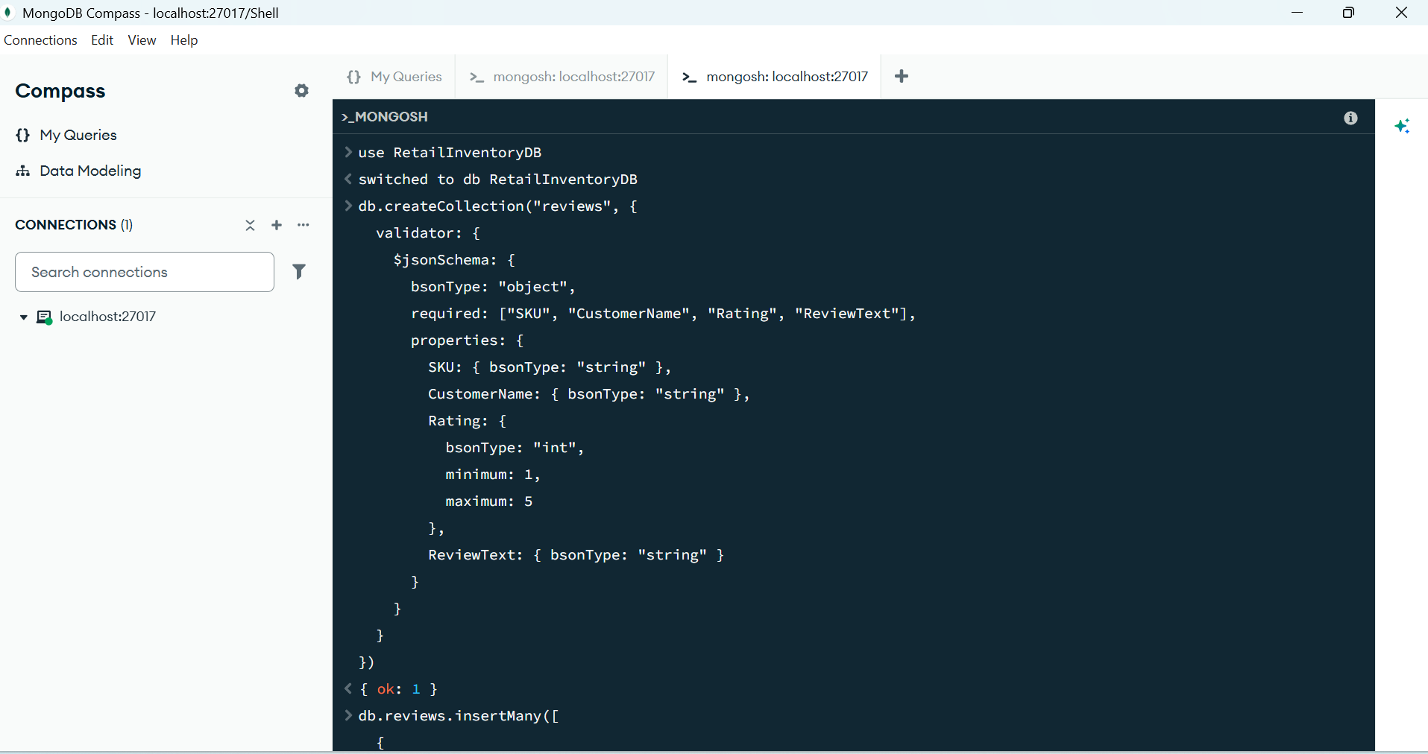
Insert 5 reviews using insertMany()
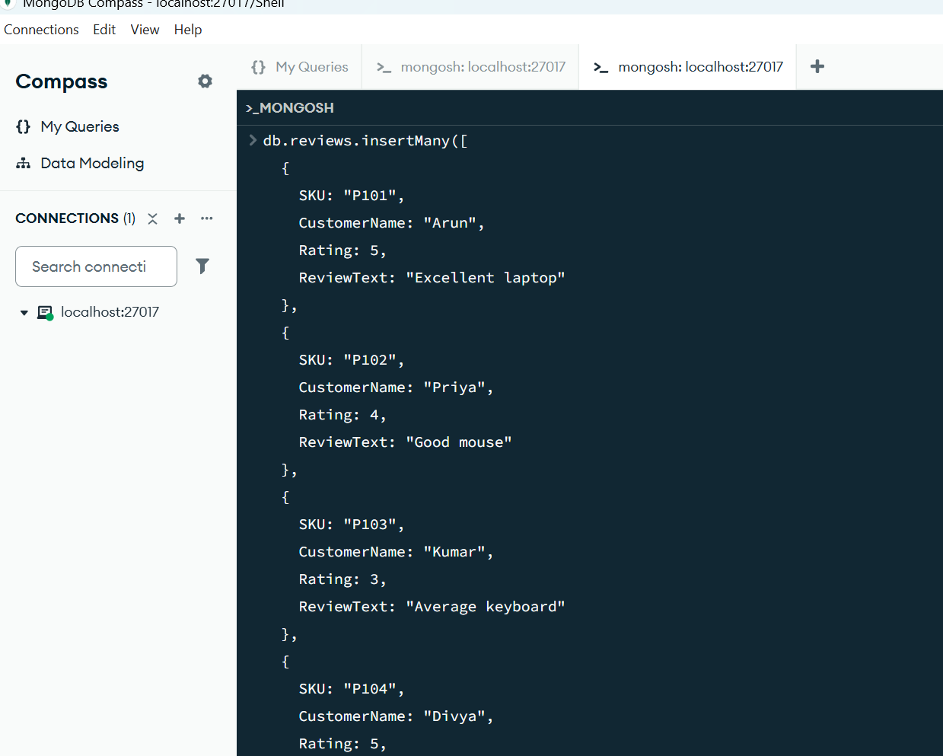

Display all reviews using find()


